AI FAQ ASSISTANT

A PROJECT REPORT
Submitted to the University of Madras in partial fulfillment of the requirements for the award of the Degree of

Bachelor of Computer Applications

DOCUMENTATION SUBMISSION

ALPHA ARTS AND SCIENCE COLLEGE
PORUR, CHENNAI – 600116

TEAM MEMBER DETAILS
Team Member ID | Name
4A7BAD7DF0AF182ACCE4847A9A08FD5A | Prathesha.R(TeamLead)  Vijaya Lakshmi.S Keerthana.A  Prasana kumari
9241E54E2BC5BFF9B5C4529E243A635C
7C739DF5C4B6C37AA044DFCF037CD6BA
6E8E4CB2164706EB35A40088EB28D0E3

1. INTRODUCTION
The project titled “AI FAQ Assistant” is developed by a team consisting of Team Lead Pratheesha.R, along with team members Keerthana.A, Prasana kumari.D, and Vijaya Lakshmi.S, in partial fulfillment of the requirements for the award of the Degree of Bachelor of Computer Applications under the University of Madras, at Alpha Arts and Science College, Porur, Chennai.
The AI FAQ Assistant is a REST API-based backend application built to manage Frequently Asked Questions (FAQs) with the help of artificial intelligence. Rather than requiring FAQ content to be written entirely by hand, the system allows an authenticated user to request that an answer be generated automatically for a given question, using Google’s Gemini AI service. The project also provides the supporting infrastructure that any FAQ platform needs — secure user registration and login, FAQ storage, and keyword-based search — all exposed as a set of REST API endpoints that can be consumed by any client application.
FAQ management is a common requirement across websites, products, and customer support systems, because it reduces repeated queries to human support staff and gives users a self-service way to find answers. However, manually writing and maintaining a large set of FAQs is time-consuming, and questions are often phrased in ways the original author did not anticipate. Artificial intelligence, and large language models in particular, can help close this gap by generating clear, well-structured answers to a question on demand, which can then be reviewed, stored, and reused as part of the FAQ collection.

2. PROJECT OVERVIEW
The AI FAQ Assistant is designed as a single, cohesive backend service that combines conventional CRUD-style FAQ management with an AI-assisted content generation capability. The purpose of the project is not simply to store questions and answers, but to reduce the manual effort involved in producing FAQ content, while still keeping that content under the control of an authenticated user. Every capability of the system is exposed through a REST API, secured where appropriate using token-based authentication, and backed by a MongoDB database.

Key Features
The following features summarise the functional scope of the AI FAQ Assistant:
- User Registration — New users can create an account by supplying their name, email address, and password, which is stored securely rather than in plain text.
- User Login — Registered users can authenticate using their email and password to receive a signed JSON Web Token (JWT) for subsequent requests.
- Secure Authentication — Passwords are hashed using bcrypt before being stored, and protected API routes verify a JWT before allowing access, so that only authenticated users can manage FAQ content.
- FAQ Creation — Authenticated users can add new FAQ records consisting of a question, an answer, and a category.
- FAQ Management — The system organises FAQ records so that they can be maintained over time, associated with the user who created them.
- FAQ Search — Users can look up existing FAQ records using keywordbased search, making it easier to find relevant answers without browsing the entire collection.
- AI FAQ Generation — The backend integrates with Google Gemini AI so that, given a question, the system can generate a natural-language answer automatically.
- MongoDB Data Storage — All user and FAQ data is persisted in a MongoDB database (hosted on MongoDB Atlas), accessed through the Mongoose object modelling library.

3. ARCHITECTURE
The AI FAQ Assistant follows a layered backend architecture. Each incoming request passes through a well-defined sequence of layers, with a single external AI service integrated alongside the core request path. The diagram below illustrates the primary request flow through the system.

Layered Architecture
Client
| v
Express Server
|
v
Authentication
(JWT / bcrypt)
|
v
Business Logic
(Controllers / Services)
|
v
Mongoose
|
v
MongoDB

+-----------------+
| Google Gemini |
| AI |
+--------+--------+
^
| v
Client -> Express Server -> Business Logic -> Mongoose -> MongoDB
This integration is implemented in a dedicated service module (src/services/geminiService.js), which keeps the AI-calling logic separate from the Express route handlers and the MongoDB data-access logic. This separation means the AI provider could, in principle, be replaced or extended without altering the routing or database layers.

Data Flow
The following two flows describe how a request moves through the system for (A) a normal FAQ operation, and (B) an AI-assisted answer-generation request.
3.3.1 Normal FAQ Flow
User
|
v
API Request (e.g. POST /api/faqs, GET /api/faqs/search)
|
v
Express Route
|
v
Authentication (JWT verification)
|
v
Business Logic (Controller)
|
v
MongoDB (via Mongoose)
|
v
API Response
| v User
3.3.2 AI FAQ Generation Flow
User
|
v
API Request (POST /api/ai/answer)
|
v
Express Route
|
v
Authentication (JWT verification)
|
v
Business Logic -> Google Gemini AI
| |
|<--------------------+ v
API Response (AI-generated answer)
| v User

4. SETUP INSTRUCTIONS

Prerequisites
The following software and accounts are required before the AI FAQ Assistant can be set up and run:
- Node.js (JavaScript runtime for executing the backend application)
- npm (Node Package Manager, used to install project dependencies)
- MongoDB (a MongoDB Atlas cluster was used during development and testing — confirmed via the terminal log “MongoDB Connected: acrjpaliyshard-00-00.ug2ngih.mongodb.net.
- Postman or Thunder Client, for testing the REST API endpoints (Thunder Client, as a Visual Studio Code extension, was the tool actually used during development.

Environment Variables
The project is configured using a .env file. The exact variable names used in the project’s .env file were not supplied as part of the project information; the example below therefore uses placeholder names that follow the values confirmed through testing (the application port) together with conventional names for the remaining

5. FOLDER STRUCTURE
The project folder structure below was confirmed directly from the Visual Studio Code Explorer panel during development and testing, rather than being assumed.
It reflects the structure of the project at the time of testing.
CODE/
|
+-- node_modules/
+-- src/
| +-- config/
| +-- controllers/
| +-- middleware/
| +-- models/
| | +-- FAQ.js
| | +-- User.js
| +-- routes/
| +-- services/
| | +-- geminiService.js
| +-- utils/
| +-- app.js
| +-- server.js
+-- .env
+-- AI_FAQ_Assistant_API.postman_collection.json
+-- package-lock.json
+-- package.json
+-- README.md
+-- test_api.js
+-- testGemini.js

6. RUNNING THE APPLICATION
After completing the installation steps described in Section 4, the application dependencies are installed using:
npm install
The exact npm script name configured in package.json to start the server (for example, npm start or npm run dev) was not explicitly supplied as part of the project information and is therefore recorded as [NPM SCRIPT NAME TO BE
CONFIRMED]. What is confirmed, directly from the terminal output captured during testing, is that the server process watches and restarts src/server.js — the terminal log reads “Change detected in … src\\config\\db.js” followed by “Restarting ‘src/server.js’” — which indicates the server is run in development mode through a file watcher such as nodemon, with src/server.js as the entry point.
With the server running, the API can be reached at the following base URL, using the confirmed port number:

http://localhost:5000
Individual endpoints (for example, http://localhost:5000/api/auth/register or http://localhost:5000/api/ai/answer) can then be exercised using Thunder Client, Postman, or any other HTTP client, as described in Section 9.

7. MODULE DOCUMENTATION

User Authentication Module
This module handles account creation and login. During registration, a new user submits their name, email address, and password; the password is hashed using bcrypt before being stored, so that the plain-text password is never persisted in the database. This behaviour is confirmed by the registration response captured during testing (Figure 12.2), which returns the user’s stored record together with a signed JWT, but never returns the password itself.

FAQ Management Module
Authenticated users can create FAQ records, each consisting of a question, an answer, and a category, together with a reference to the user who created it (createdBy) and automatic timestamps. The module is designed to support the standard lifecycle of an FAQ record — creation, update, and deletion — through the endpoints described.

AI FAQ Generation Module
This module integrates the backend with Google Gemini AI to reduce the manual effort of writing FAQ answers. A client submits a question; the geminiService.js service module forwards this question to the Gemini AI API and returns the generated natural-language answer in the API response. This behaviour was directly confirmed during testing: a POST request to /api/ai/answer with the request body { "question": "what is mongoDB?" } returned a 200 OK response containing a complete, well-formed answer generated by Gemini AI , with a measured response time of 4.77 seconds.
It is worth noting for accuracy that the endpoint confirmed through testing is POST /api/ai/answer. This document uses that confirmed route name throughout, in preference to any endpoint name assumed before testing evidence was available.

FAQ Search Module
The FAQ search module allows a client to retrieve FAQ records that match a given keyword, via a GET request with a query parameter (for example, GET /api/faqs/search?q=mongodb). This provides a lightweight, self-service way for a user to locate relevant existing FAQ content without needing to browse the full collection.

Database Module
Data persistence is provided by MongoDB, accessed through the Mongoose object data modelling (ODM) library. Mongoose schemas define the shape of the User and FAQ collections (see Section 8), and provide validation and query helpers used throughout the controller layer. The MongoDB connection itself is established in src/config/, and a successful connection to a MongoDB Atlas cluster was confirmed in the terminal log during testing. .

API Routing Module
Express routes, defined under src/routes/, organise the application’s endpoints into logical groups — authentication routes, FAQ routes, and AI routes — and connect each URL path and HTTP method to its corresponding controller function. This keeps the routing configuration separate from the business logic implemented in the controllers.

8. DATA MANAGEMENT
The AI FAQ Assistant stores two primary types of data in MongoDB: user accounts and FAQ records. Each is represented by its own Mongoose schema, summarised in the tables below. Data types are marked as confirmed where they were directly observed in API responses during testing, and are otherwise left unspecified in line with the project’s accuracy requirements

9. API INTERFACE
As the AI FAQ Assistant is a REST API-based backend project with no bundled front-end, its interface is the set of HTTP endpoints it exposes. During development, these endpoints were exercised using Thunder Client, a REST client extension for Visual Studio Code (confirmed directly by the captured screenshots in Section 12). A Postman collection (AI_FAQ_Assistant_API.postman_collection.json) is also maintained within the project for the same purpose, allowing the API to be tested from either tool.

Endpoint Detail: POST /api/auth/register
Purpose: registers a new user account. This endpoint was tested directly, with the following confirmed request and response.
The response was observed with HTTP status 201 Created, a size of 323 bytes, and a response time of 605 ms. Note that the JWT shown above has been shortened for readability; the full token was returned in the actual response.

Endpoint Detail: POST /api/ai/answer
Purpose: accepts a question and returns an AI-generated answer produced via Google Gemini AI, which can be used as the basis for a new FAQ entry. This endpoint was also tested directly.
Request Body:
{
"question": "what is mongoDB?"
}
Response (200 OK):
{
Request Body:
{
"name": "saran",
"email": "user22@gmail.com",
"password": "password123"
}
Response (201 Created):
{
"success": true,
"message": "User registered successfully",
"data": {
"_id": "6ab4f2a2d0e60abfd8a7cee9",
"name": "saran",
"email": "user22@gmail.com",
"token": "eyJhbGciOiJIUzI1NiIsInR5cCI6IkpXVCJ9..."
}
}
"answer": "MongoDB is a document-oriented NoSQL database system that stores data in flexible, JSON-like documents with dynamic schemas. It is designed for high performance, high availability, and easy scalability."
}

Other Endpoints
Requests and responses for POST /api/auth/login, POST /api/faqs, and GET
/api/faqs/search were not captured during testing and are therefore not reproduced here.
For these endpoints:
Request Body: [REQUEST BODY TO BE CONFIRMED]
Response Format: [RESPONSE FORMAT TO BE CONFIRMED]
These should be completed by re-running each endpoint in Thunder Client or Postman and recording the captured request and response, in the same manner.

10. STYLING AND RESPONSE FORMAT
As the AI FAQ Assistant is a backend REST API project, it has no front-end styling (CSS) to document. Instead, this section describes the conventions used for structuring API responses and organising backend code.

JSON Response Structure
Successful responses observed during testing consistently follow a JSON structure containing a boolean success flag, together with either a data payload, a message, or, for the AI endpoint, an answer field, as shown in Section 9. This gives client applications a predictable shape to parse, regardless of which endpoint was called.

HTTP Methods
The API uses standard HTTP methods according to the action being performed: POST for creating resources or triggering an action (registration, login, FAQ creation, AI answer generation) and GET for retrieving data (FAQ search). This follows conventional REST practice, mapping each verb to its corresponding CRUD-style operation.

Backend Code Organisation
Response construction and formatting logic is kept within the controller layer (src/controllers/), separate from the Mongoose data-access logic (src/models/) and the routing configuration (src/routes/). This separation of concerns, visible directly in the confirmed folder structure (Section 5), keeps the code organised and makes it easier to maintain consistent response formatting across endpoints.

11. TESTING

Testing Strategy
The AI FAQ Assistant was tested using Thunder Client, a REST client extension within Visual Studio Code, as directly evidenced by the captured screenshots in Section 12. Testing followed a logical order: registration and login were tested first to obtain a valid JWT, after which the protected FAQ and AI-generation endpoints could be exercised using that token.

Authentication Testing
Registration was tested with a sample user (name: saran, email:
user22@gmail.com) and confirmed to return HTTP 201 Created with a valid user record..

FAQ Testing
Direct testing evidence for FAQ creation (POST /api/faqs) was not available at the time of writing this documentation.

Search Testing
Direct testing evidence for FAQ search (GET /api/faqs/search) was not available at the time of writing this documentation.

AI Generation Testing
The AI answer-generation endpoint (POST /api/ai/answer) was tested with the question “what is mongoDB?” and confirmed to return HTTP 200 OK with a complete, coherent AI-generated answer within 4.77 seconds (see Figure 9.2).

Database Testing
A successful MongoDB Atlas connection was confirmed via the terminal log (“MongoDB Connected: ac-rjpaliy-shard-00-00.ug2ngih.mongodb.net”), and the persistence of a newly registered user was implicitly confirmed by the presence of a generated MongoDB ObjectId (_id) in the registration response.

Protected API Testing
The Thunder Client interface for the AI answer endpoint shows an Auth tab alongside Query, Headers, and Body, indicating that authentication details SCREENSHOTS / DEMO :
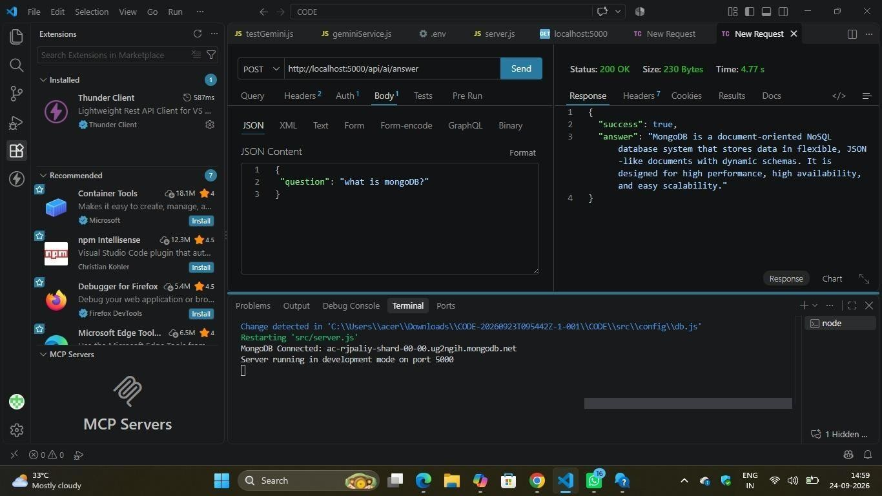

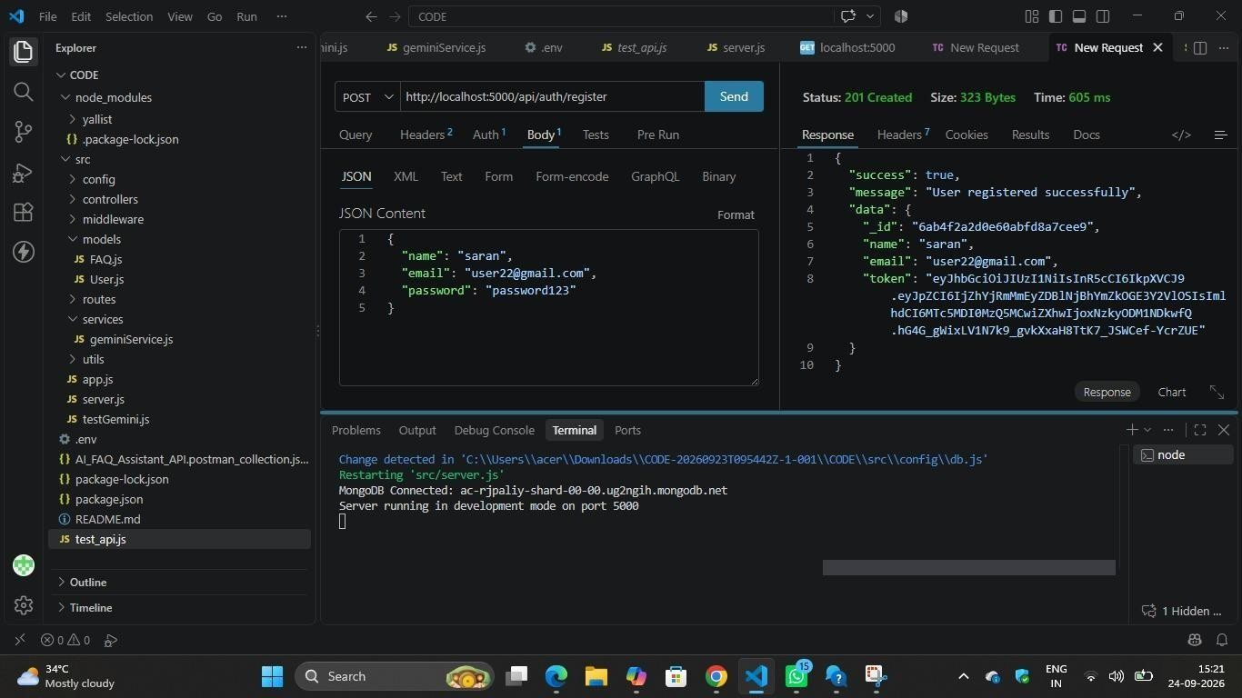
The following figures are placeholders for screenshots that were not supplied at the time of writing this documentation and should be added before final submission:

13. FUTURE ENHANCEMENTS
The following are reasonable directions for extending the AI FAQ Assistant beyond its current scope. These are proposed future enhancements only and do not describe features that currently exist in the system:
- Role-based access control, allowing different permission levels (for example, admin versus regular user) for managing FAQ content.
- Advanced FAQ search, including filtering by category, fuzzy matching, or relevance ranking rather than simple keyword matching.
- Pagination for FAQ listing and search results, to handle larger FAQ collections efficiently.
- FAQ filtering by category, tag, or creation date.
- Improved AI prompt handling, including prompt templates and response formatting tailored specifically to FAQ-style answers.
- API rate limiting, to protect the service (and the underlying Gemini AI quota) from excessive or abusive request volumes.
- Logging and monitoring, to track API usage, errors, and AI response times in production.

14. CONCLUSION
The AI FAQ Assistant demonstrates the design and implementation of a secure, AI-integrated backend system for managing Frequently Asked Questions. By combining Node.js and Express.js for the REST API layer, MongoDB and Mongoose for data persistence, JWT and bcrypt for authentication and password security, and Google Gemini AI for automated answer generation, the system brings together the core components required of a modern backend service within a single, coherent architecture.
Testing carried out during development, using Thunder Client, confirmed that the core registration flow and the AI-assisted answer-generation flow both function as intended: a new user can be registered and issued a JWT, and a submitted question can be answered automatically by Google Gemini AI through the POST /api/ai/answer endpoint, with the underlying MongoDB Atlas connection and Express server both verified through the application's terminal output.

DEMO LINK:
https://drive.google.com/file/d/1mdGhcLm009K-bZJAlwPvuw9gvjwdrIhG/view?usp=drivesdk
GITHUB LINK:
https://github.com/prathesha18/Prathesha-R.git

